WHY DO WE EAT?

Animal Cells and Metabolism

MIDDLE SCHOOL UNIT

TEACHER GUIDE

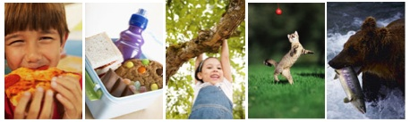

March 2009

Michigan State University

Environmental Literacy Project

Lindsey Mohan and Andy Anderson

Table of Contents

Unit Overview and Background 3
Embedded Assessments 6
Materials List 7
Activity 1: What Is In The Foods We Eat? 8
Activity 2: What Happens To The Food We Eat? 20
Activity 3: Food Helps Animals Grow……………………………………………………………………….28
Activity 4: Food Helps Animals Move 34
Activity 5: Cell Respiration………………………………………………………………………………………41
Activity 6: What Happens When Animals Lose Weight…………………………………………….50
Activity 7: Assessment or Extension: Black Bear Article 54

RESOURCES:
Anderson, C. W., Roth, K.J., Hollon, R., Blakeslee, T. (1987, November). The Power
Cell: A Teacher’s Guide to Respiration. Occasional Paper No. 113. The Institute
for Research on Teaching, Michigan State University.
Rogers, L. (1992). Watchable wildlife: the black bear. USDA Forest Service, North Central
Forest Experiment Station, St. Paul Minnesota.
Lundberg, D. A., Nelson R. A., Wahner, H. W., Jone, J. D. (1976), Protein metabolism in the
Black bear before and during hibernation. Mayo Clinic Proceedings. 51(11): 716-22.

Unit Overview and Background

Our work on the Environmental Science Literacy Project has been to document the accounts students have for events that occur in natural and human social systems. At the macroscopic scale we documented students’ accounts of growth, weight loss, decay and burning and at the large scale we looked at their accounts of global warming and deforestation. The goal of our work has been to develop a learning progression that describes how accounts of changes in matter and energy develop from grades 4-12. One important conclusion from this work, and our experiences in classrooms, is the following: When students enter school they use narratives (or stories) to explain how the world works. This is the students’ natural discourse. The information they learn in science class teaches them more detailed narratives and new vocabulary, and students try to fit the new information into their existing narratives. Thus, students tell the same stories with more details, instead of learning new, more principled accounts about their world.

Our carbon cycle learning progression describes what we observed from students at different levels (and different age groups). We used this information to design classroom materials that support (productive) progress toward building new accounts about the world—specifically to build principled accounts about carbon cycling.

The carbon cycle learning progression levels: Our learning progression is comprised of four Levels of Achievement:
- Level 1 students (at the lower anchor of the learning progression) use force-dynamic reasoning (Pinker, 2007; Talmy, 1988) in which actors (e.g., animals, plants, flames) use enablers (e.g., air, water, food, fuel, sunlight) to fulfill their natural tendencies. Events result from the interplay between the natural tendencies of agents and the balance of forces between enablers that support actors in fulfilling their capacities, and antagonists, which can prevent this from happening.
- At level 2 students are still guided by force-dynamic reasoning, but can point to hidden mechanisms that move beyond natural tendencies and begin to recognize the need to trace materials in and out of systems. Gases are treated more like conditions as opposed to “real matter” and matter and energy are not distinguished.
- At level 3 students begin to recognize chemical changes at a cellular and atomic-molecular level and use chemical identities for several important substances. Some level 3 students attempt to conserve both matter and energy without necessarily knowing great detail about chemical substances and processes. However, some level 3 students also may have difficulty with consistently applying conservation principles (i.e., convert matter and energy; ignore gases).
- At level 4 students see events as “chemically” similar or different and can reason about events in terms of chemical substances and processes. They can also fluidly move between different scales in their reasoning.

In general, most middle school students give levels 1 and 2 accounts on our assessments (69%). Only 20% of students give level 3 accounts. Therefore, an important goal for middle school students would be to get them to make progress toward level 3 reasoning. This involves supporting students in recognizing and using important principles to guide their reasoning. In particular, this unit helps students use SCALE, MATTER, and ENERGY principles and introduces students to several tools that support reasoning with these principles.

The overview below describes the progression of activities. Students will focus on 4 key processes during this unit: Digestion, Growth, Movement, and Weight Loss (the latter two are about cell respiration). They will use the process tool to describe what happens to matter and energy at the atomic-molecular, cellular and macroscopic scales.

Number | Activity Title | Topic | Time
1 | What Is In The Foods We Eat? | Students find out what is in the foods they eat by looking at labels for materials found in food, such as proteins, fats, carbohydrates and vitamins. They explore what it means for foods to have chemical energy, and how this helps to determine what is and is not food. | 60 minutes
2 | What Happens To Foods That We Eat? | Students move beyond the organismal, macroscopic scale to trace food through organs to cells. This engages students in thinking about digestion at a microscopic scale. | 50 minutes
3 | Food Helps Animals Grow | Students conduct a mealworm growth investigation. They collect data for at least 1-2 weeks learn that some food stays in the body of the mealworm to help it grow. Students use the process tool to explain what happens to matter and energy during growth | 2-week investigation and at least 30 minutes discussion of results/  conclusions
4 | Food helps Animals Move | Students revisit their investigations and think about why the mass of the overall cup is decreasing when the worms are growing. Students engage in exercises to identify macroscopic indicators that matter and energy change when they move. They use the process tool to show these changes and identify that gases help explain how some food materials change in the body. They also can read about why air/oxygen is important for movement tracing this substance to cells. | 50 minutes
5 | Cell Respiration | Students read about and use molecular model kits to show what happens to molecules inside the cell. They connect the modeling activity to the observations during activity 3 and 4.
6 | What Happens When Animals Lose Weight | Students observe a cup of crickets and record the changes in mass across a couple of school days and discuss why the crickets are losing mass. They learn that weight is lost because the stuff that makes up animal bodies changes into gases in the air. | A couple of school days with about 30 minutes of discussion
7 | Black Bear Activity | Students read about black bear hibernating in the cooler months and use what they learned about cell respiration and weight loss to explain macroscopic changes in the bear during and after hibernation. | 50 minutes.

Embedded Assessments

To Copy for Environmental Literacy Group (for 12 Focus Students). Page numbers are noted from the teacher’s guide.

- Exploring Food Labels (chart/questions) (page MS AN 14-15)
- Why Do We Need To Breathe and Eat? (pages MS AN 22)
- What Happens to the Food We Eat? (pages MS AN 23-26)
- Mealworm Observations (pages MS AN 31-32)
- What Happens When Animals Grow (page MS AN 33)
- Food Helps Animals Move (page MS AN 37)
- Modeling Cell Respiration (pages MS AN 45-49)
- Cricket Observations (pages MS AN 52-53)
- Black Bear Hibernation (pages MS AN 56-60)

Materials List

TEACHER TOOLS
Overhead projector, blank transparencies, vis-à-vis markers
Computer and Projector
Process Tool- Digestion, Growth, Movement/Respiration, Weight Loss/Respiration
Groceries or other examples of food labels *optional

OVERHEAD TRANSPARENCIES, POWERPOINTS, ETC
Powers of Ten Finger.ppt (zooming into a finger/animal cell)
Powerpoint Set: Tracing Food and Air
Food Molecules transparency for Lesson 1
Sugar and Fats & Respiration transparencies for Lesson 7

GROUP MATERIALS
10 sets of Food Labels (nine food labels)
What is in the Foods We Eat reading
Air is Important For Movement reading
What Is Cell Respiration reading

STUDENT WORKSHEETS (embedded assessments to copy)
What Is In The Foods We Eat
Exploring Food Labels (chart)
Why Do We Need To Breathe and Eat?
What Happens to the Food We Eat?
Mealworm Observations
What Happens When Animals Grow?
Food Helps Animals Move
Modeling Cell Respiration
Cricket Observations
Black Bear Hibernation

LAB MATERIALS
Mealworm larvae (100g bought at local bait or pet shop)
20g of crickets (field or house bought at local bait or pet shop) 15 crickets ~ 3g
Bran cereal
Paper cups
Glass beaker
Digital Balance
Tweezers
BTB solution
Clear cups or beakers
Straws

Activity 1: What Is In The Foods We Eat?

General Overview
Introduce Nutrition Labels ~15 minutes
Small Group Work- Nutrition Labels ~20 minutes
Whole Class Summary Discussion ~20 minutes

Total Estimated Time: 55 minutes

Purpose
In this activity students will start to develop a scientific definition of food. Students are likely to define food very broadly as something that helps organisms live and grow. Other students may contrast food with liquids/beverages. Although food does help organisms live and grow, students using a broad definition for food will consider anything as food for organisms. Many students may consider water and vitamins as food similar to sugar. Students using a broad definition of food do not have a way to distinguish between energy-rich materials, such as sugars, starches, and fats, that humans and animals take in compared to water and vitamins. In this activity, students will explore food labels for common items that can be purchased at the grocery store. Students will learn that foods contain carbohydrates (starch and sugars), fats, and proteins, and that these things have chemical energy. They will discuss the concept of “calories” and how scientists use calories to determine the amount of chemical energy in food. Students will be given a “scientific definition” of food based on the idea that food contains chemical energy that helps organisms (cells) function. They will also look at vitamins and water and discuss whether these can be considered “food” for the body when they do not have chemical energy. Students will look at nine food labels and discuss how they can decide whether something is “food” or not food for organisms.

Materials
Student copies of What Is In The Foods We Eat reading
Student copies of Exploring Food Labels (chart)
10 group sets of Food Labels (nine food labels)
Overhead copies of each of these *optional
Groceries or other examples of food labels *optional

Advance Preparation
Make copies and overheads if these are not provided by MSU
Review lesson plan

Procedures

What Is In The Foods We Eat? ~15 minutes
The introduction of this activity should be completed by the whole class (before students break into small groups to work on the activity). It introduces students to nutrition labels, and the key “content” on those labels. It also introduces a scientific definition of food.

Read the introduction to students. Then have them look at the carrot label and ask, “By looking at this label, what things are found in the carrots?” (students may notice carbohydrates, proteins, fats, calories, vitamins, sodium, etc). If you have time, you can allow students to explain where they have heard some of these terms before. This will provide you with a sense of the students’ prior knowledge about foot labels, and possible misconceptions they will have as they develop an understanding of “food” and “chemical energy”.

Then move onto page 2. Read this to your students or select a student to read. As the class reads the teacher will want to stop at least 3 points to point out key ideas or answer questions:
- After reading the paragraph that begins “scientists use “calories” to measure”; stop the class and point out that calories help determine if something has chemical energy.
- After reading the definition of food, ask the students if this definition of food is the same or different from how they define food. For example, some students may think that everything we take into our mouths constitutes food, so it’s important to point out that the scientific definition of food is different from that belief.
- Have students write their ideas for how they can use the scientific definition of food, and what they learned about “calories” to decide if something is food or not. Have the students share their ideas with the class. (with the goal of getting students to notice that things with calories have chemical energy. Things that do not have calories, cannot provide chemical energy, and therefore are not food).

On page 3 students consider whether proteins, carbohydrates and fats are food? These things are labeled as the building blocks of food. They are told that these have calories and must decide whether this means they are food.

Students are also told that vitamins and minerals do not have calories, so they must decide if vitamins and minerals are food.

At the end, explain to students that they will be examine food labels in small groups to figure out what is food using the scientific definition of food.

Small Group Label Reading ~20 minutes
Place students in groups of 2-3 and pass out “exploring food labels” chart and a packet that contains 9 food labels. Read the instructions to students. Tell them that they will go through each of the food labels and write down information that will help them decide if something is food or not. Review the table with the class, pointing out the information they will need to record in the table. Tell the groups that once they are done with their table they need to discuss and respond to the 5 questions at the end of the activity.

Summary Discussion ~20 minutes
Review the 5 questions at the end of the activity.

First ask which things in the list met the scientific definition of food. This should include everything except water. Identify any areas of disagreement. If disagreement exists, have students justify whether something is food or not using the information on the food label. Then ask students if anything in this list surprised them. Student may be surprised or confused that milk, apple juice and candy are considered food because these substances are often treated as “drinks” or not substantial enough to constitute food. Point out that these contain the basic building blocks of food, and have calories, so they provide chemical energy for the body.

Ask students what these foods have in common and why we can call them foods (chemical energy).

Point out that scientific definition of food says that food can be in the form of solid or liquid, as long as it has chemical energy.

Ask students if anything was not a food (water) and why it cannot be considered a food. Remind students that water is very important for the body and that we need it to stay alive, but that it is not considered “food” because it cannot provide chemical energy.

The last question is intended to get them to share their initial ideas of digestion, and how food travels in the body. This question can be discussed today or used at the beginning of the next lesson.

NOTE: Consider using the Food Molecules transparency to get at an atomic molecular understanding of food molecules. Have students compare glucose and a lipid and identify that both contain the same type of atoms and high-energy bonds, but that glucose is not as complex. Students can relate this complexity to the everyday experiences of “sugar highs”.

What Is In The Foods We Eat?

You have probably seen nutrition labels that are found on most food packages. Scientists use tests to find out what makes up the foods we eat, and then food companies use labels so that people who buy their products also know what makes up the foods. Today you will work with your group to explore different food labels and you will think about why our bodies need the nutrients found in food. First you need to understand how to read the food labels. Look at the food label below. This food label is for carrots.
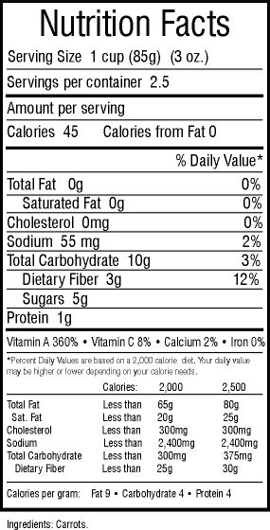

Just by looking at this label, what are some things that make up the carrots that we eat?
Now, take a closer look at the label and think about what each of the things provide our bodies.
What are calories?

Take a look at the things included in the black box. The label shows that there are 45 calories in one serving of carrots. But what does this mean?

Scientist use “calories” to measure how much chemical energy is found in foods. Foods that have calories are a good energy source for our bodies. Things that do not have calories cannot provide energy for our bodies.

Food is our only source of chemical energy. All the trillions of cells in our bodies need food because it’s our only source of energy. Energy is so important to our cells that scientists define food as:

FOOD refers only to materials that contain chemical energy for living things. It is material that living things use for energy to live and grow. All living things must use the chemical energy in food to grow and to keep all their parts working properly.

Now that you know that “food” must provide chemical energy, how can you use the information on food labels to tell you whether something is food or not? Talk with your classmates.
What are the basic building blocks of food?

Some things found in foods have chemical energy but some things do not. The basic building blocks of food are carbohydrates, proteins, and fats. Carbohydrates include sugars, starches, and fiber. Carbohydrates are found in most foods, especially breads, pastas, sweets, and vegetables, like potatoes. Proteins are found in many foods, especially meats, beans, and dairy. Fats are found in many foods, especially oils and butter that we for cooking and baking. These three things have calories, which means they have a lot of chemical energy for our bodies.

Would carbohydrates, proteins, and fats be “food” using our definition of food?

What about vitamins?
Look at the label carefully. Can you find the vitamins and minerals that are found in carrots? What are they?

Vitamins and minerals are important for our bodies to stay healthy. But vitamins and minerals do NOT contain calories, which means they do not provide chemical energy for our bodies.

Would vitamins and minerals be “food” using our definition of food?

Now you will work with a group to look at different nutrition labels. In your group you will need to decide what things are food for our bodies and what things are NOT food.
Name: __________________________________________ Date: _____________________
Exploring Food Labels
Your group will be given food labels. Look at each label carefully and fill in the table below. Once you have looked at all your food labels, discuss the questions on the following page. Think carefully about these questions and write down as much as you can because you will need to share your ideas with the class.

Food Label Data Table: |  | Chemical Energy |  |  |  | Other Things
Label | FOOD NAME | How many calories does it have? | How many carbohydrates does it have? | How much fat does it have? | How much protein does it have? | What types of vitamins and minerals does it have? | Is this “food” using our definition of food?  YES or NO
1
2
3
4
5
6
7
8

9

Exploring Food Label Questions
- Which things in your list are “food” using our definition of food?
__________________________________________________________________________________________________________________________________________________________________________________________________________________

2. Why are these things food? What do they provide your body that makes them food? ______________________________________________________________________
__________________________________________________________________________________________________________________________________________________________________________________________________________________

3. What things in your table are NOT food (do not have chemical energy)?
__________________________________________________________________________________________________________________________________________________________________________________________________________________

4. What is the difference between things that are food for your body and things that are not food? ______________________________________________________________ ________________________________________________________________________________________________________________________________________________________________________________________________________________________________________________________________________________________

5. Do you have any ideas about what happens to food once it goes inside your body (How does the body get the chemical energy in food)? __________________________
________________________________________________________________________________________________________________________________________________________________________________________________________________________________________________________________________________________
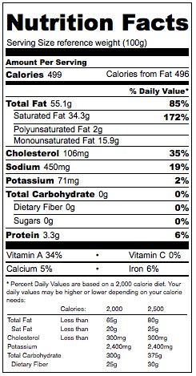
BUTTER
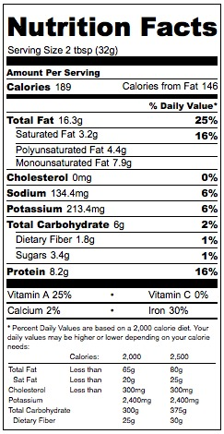
CARROTS
PEANUT BUTTER
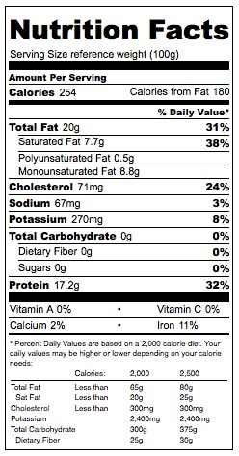
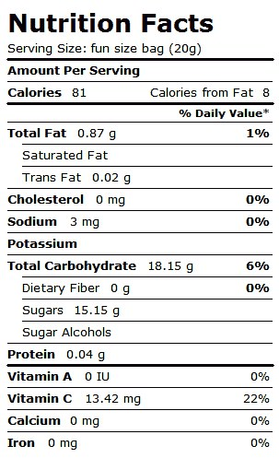
HAMBURGER MEAT
SKITTLES CANDY
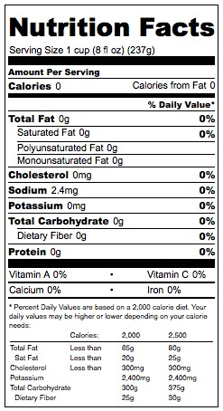
WATER

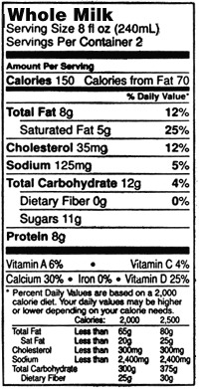
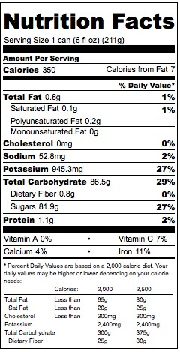
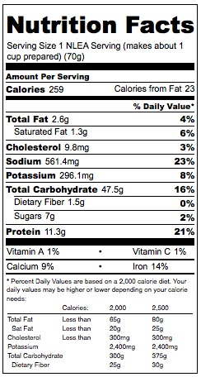
WHOLE MILK
APPLE JUICE
KRAFT MAC N’ CHEESE

Food Molecules
Look at the two diagrams. One is a fat molecule and the other is glucose (a sugar molecule; carbohydrate). The letters stand for atoms: C for carbon atoms, H for hydrogen atoms, and O for oxygen atoms. The lines between each atom represent a bond.

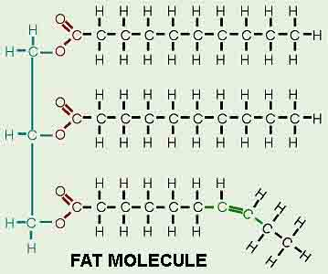
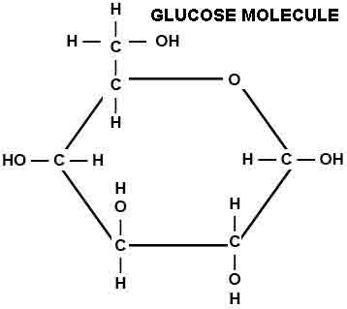

Do you see similarities between them?

Do you see differences between them?

Activity 2: What Happens To The Food We Eat?

General Overview
Share initial ideas of what happens to food from Activity 2 ~ 10 minutes
Why do we need to breathe and eat? ~ 15 minutes
How does food travel in the body? ~ 25 minutes
Powerpoints: ~10 minutes

Total Estimated Time: 55 minutes

Purpose
In the previous lesson students talked about food as being a source of chemical energy. They begin Activity 3 reviewing their initial ideas to question 5 in the previous activity- what happens to food in our bodies (how do we get chemical energy). The purpose of this activity is for students to trace food through the human body to cells. Students learn about digestion and the key body organs involved in digestion, as well as circulation that takes food to the cells. The point of the activity is to help students move beyond the organismal and organ scale—to trace food to a microscopic, cellular scale and identify molecules at an atomic-molecular scale. It is important that students realize food enters the body in solid and liquid forms (and has chemical energy) BUT that food is not energy itself. Be attentive to how students use language to describe this during class discussions because equating “food” with “energy” (and using the two terms synonymously is an indication that students may not understand matter and energy.

Materials
Copies of Why Do We Need To Breathe and Eat?
Copies of What Happens to the Food We Eat?
Powerpoint: Trace Food through body
Powerpoint: Zooming into a finger

Advance Preparation
Make copies of student handouts if not provided by MSU
Make overheads if not provided by MSU

Procedures

Share Initial Ideas about Digestion ~10 minutes
Have students share what they learned about food and food labels in the previous lessons. Remind students about the scientific definition of food (materials that contain chemical energy) and explain that they will be talking more about food today. Ask students to share their ideas to Question 5 of the previous activity: What happens to food once it is inside our body?

Why Do We Need to Eat and Breathe? ~15 minutes
As a class, read through “Why do we breathe and eat?” Ask the students to think about and respond to the questions at the bottom of the first page. These questions can serve as a pre-assessment of what students understand about digestion and getting food to cells. Some key ideas that will be discussed in today’s lesson are that food must be transported to cells so that they can work to help us grow and move around.

How Does Food Travel in the Body? ~25 minutes
In partners or as a class, let the students read through and respond to the remainder of the reading. Questions are intermixed with the reading. The following are suggestions for when to stop the class and point out key ideas in the reading:
- Stop after the scientific definition of food and ask them what they remember was and was not food for the body? (FOOD: carbs, proteins, fats; NOT FOOD: water and vitamins).
- After students read about the three reasons that we need to eat, ask them how those three things compared to what they wrote. Does the third option make sense to them using the scientific definition of food?
- Go through questions 5-7 and ask them to use what they learned on nutrition labels to answer the questions (water, vitamins do not have chemical energy BUT sugar does have chemical energy so sugar can be considered food).
- Read about the stomach and small intestines, then ask students “where does the useful parts of food go after it reaches the intestines, and how does it get there?” Have them write and share ideas to question 8.
- On the next page read about how food is taken by the circulatory system to cells and have students write and share ideas to question 9
- Read about what cells do with food- it is important for students to realize that cells do three things with food- GROW, STORE, or USE (to move, function, or stay warm).
- Have students share their ideas to Question 10

Use the powerpoint set/transparencies to help “trace” food through the body systems.

Use powerpoint to zoom into a finger and talk about the different between scales. Are what scale is a cell? How does the visible food we eat get small enough to make it to the cells? (digestion breaks it into smaller carbohydrate, fat, and protein molecules)

Name:____________________________________ Date: _________________

Why do we need to breathe and eat?

Every day you breathe in and out about 20, 000 times! In your lifetime so far, you’ve breathed in and out about 9, 000,000 times! You’ve also eaten food three to four times a day since you’ve been alive. That’s about 15,000 meals in your lifetime so far! Eating and breathing are obviously very important to you—you do them both all the time. You have to eat and breathe to stay alive. Have you ever wondered why your body needs so much oxygen and food? What happens to all that air and food you take into you body? Do you know why breathing and eating are necessary for life? Most of us eat and breathe every day and have no idea why! Today you will learn why you eat food all the time. Then you will learn about the air that you breathe. You will get to know something about things going on inside your own body right this very minute. Then you will understand why it is necessary for you to breathe and eat.

Think of taking a bite of pizza. What happens to the pizza once it is inside your body? Think about and discuss the following questions with your class:

- After you eat the pizza, where does it go inside your body? ____________________
__________________________________________________________________________________________________________________________________________________________________________________________________________________

- Do you think your body uses the materials in the pizza to grow? If so, how? _______
____________________________________________________________________________________________________________________________________________

3. Do you think your body uses the materials in the pizza to walk and run? If so, how?
______________________________________________________________________
______________________________________________________________________

Name:_____________________________________ Date: _________________

What Happens to the Food We Eat?
Earlier you were asked to respond to the question: What happens to the food that we eat?

You might have written an answer similar to the ones below:
- We need to eat because we would die without food.
- We need to eat because food helps us live and grow.
- We need to eat because food is our cells’ only source of chemical energy.

All three statements are correct, but they are not all good explanations of why we need to eat. Scientists would say that the third answer is the best one because it explains HOW our bodies use the food we eat: food is our cells’ only source of chemical energy.

Food is our only source of energy. All the trillions of cells in our bodies need food because it has chemical energy. If all of your cells need food, how do you think food gets to all the cells in your body? Food definitely enters your mouth, but how does food reach cells in your toes? Your thumb? Your ears?

Think about taking a bite out of an apple. That bite of apple is really a mixture of many different materials. It contains many materials your body can use: water, vitamins and minerals, and sugars. Which of these are materials that provide your body with chemical energy?

1. Does the water provide your body with chemical energy? __________
2. Do the vitamins and minerals provide your body with chemical energy? __________
3. Does the sugar provide your body with chemical energy? __________

Let’s trace this bite of apple through your body: from your mouth to cells in your toes!

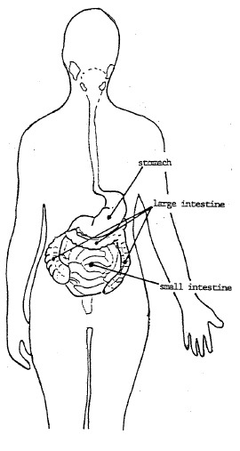
Stomach and small intestine
As you chew the bite of apple, you mash it up with your teeth and mix it with the saliva in your mouth. Then you swallow. The apple’s first stop is your stomach. It is mixed with digestive juices and is sent on to your small intestine. There, different parts of your apple bite go different ways.

The useless parts of the apple – the fibers, bacteria, and dirt – keep going through your intestines. They go from the small intestine to the large intestine and then right out of your body as feces.

The useful parts of the apple – the water, vitamins and energy-containing food – do NOT go on to the large intestine. They are carried to all the cells of your body.

4. What might carry them there? ___________________________________________
__________________________________________________________________________________________________________________________________________________________________________________________________________________

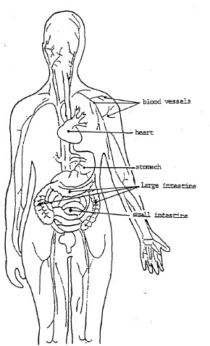
Your blood
Your blood! Food and other useful materials go through the walls of your small intestine and into tiny blood vessels. Then the blood carries those useful materials all over your body. A blood vessels pass near every single living cell in your body! The cells take the materials they need from your blood. Most people don’t realize how MANY tiny blood vessels they have in their bodies. We tend to think about the big vessels that we can see by looking carefully at our skin. But there are millions of tiny blood vessels in our body. If we lined them up end-to-end, they would go twice around the earth!

5. Why do we need so many tiny blood vessels? _______________________________
__________________________________________________________________________________________________________________________________________________________________________________________________________________

Your cells take the food they need out of your blood.

Then your cells do one of several different things with the food:
- GROWTH & STORAGE: Some food is used by cells to make new cells. That’s how you grow. If you eat more food than you need, some of the food is stored for the future. Fat is your body’s way of storing extra food.
- USE: Most of the food that reaches your cells is broken down to supply energy for your cells to work. This is how your body keeps all its parts working!

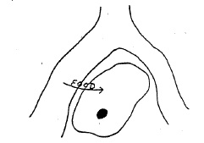

6. Describe how a muscle cell in your finger gets the food it needs to give it the energy needed to write this answer. Describe the path food takes to get to your cell and the things that might happen to food once it reaches your cells.
____________________________________________________________________________________________________________________________________________________________________________________________________________________________________________________________________________________________________________________________________________________________________________________________________________________________________
Use powerpoint to help students trace food from mouth to the cells.

Use powerpoint to zoom into a finger and talk about the different between scales.
Activity 3: Food Helps Animals Grow

This is a lab investigation that spans at least a week or more. This activity plan includes information for setting up the investigation and the discussion of results. If necessary, mealworms can be substituted with a different organisms. The general goal of the activity is to teach students that animals gain mass (grow) by incorporating some of the food they eat into their body structure.

General Overview
Day 1:
Set Up Mealworm investigations ~40 minutes

Ongoing: Record Mealworm Data over time ~60 minutes

Day 2:
Review mealworm data for patterns/conclusions ~ 20 minutes
Process Tool for growth ~ 20 minutes

Total Estimated Time: 2.5 hours across 2 weeks

Purpose
Students conduct mealworm investigations to measure mass changes as mealworms grow. Students observe that mealworm mass increases as they eat food, and the mass of food decreases. Thus, their investigations show that the growth of mealworms comes from food. BUT students also observe that the changes in mealworm mass is not the same as changes in food mass (and that the overall mass of the system decreases). This activity help students conclude that only part of the food taken in by animals contributes to growth, but that something else happens to food setting the stage for talking about how cells use food and change it to gases. Students also complete the process tool for growth.

Materials
5-10g of Mealworm larvae per group
15-20g of bran cereal per group
Large Paper cups or plastic containers for storing the larvae during investigations
2 small paper cups used for separating larvae from food (if necessary)
Digital Balance
1 Tweezer per group
Copies of Mealworm Observations
Copies of What Happens When Animals Grow?
Overheads to record/compare student data
Process Tool for Growth

Advance Preparation
Make copies of student handouts if not provided by MSU
Buy at least 100g of mealworm larvae from local pet or fishing store (make sure that each group has at least 5-10g of mealworm larvae
Buy bran cereal
Buy or gather at least 10 paper cups, tweezers, and have digital scale ready for use.
Procedures

Setting Up Mealworms
Prior to Activity 4, set up the mealworm investigations. This investigation should occur during a 1-2 weeks period so that the growth of mealworm larvae are obvious. Students will conduct an investigation in which they track the mass change in their cups—the overall mass change in both the mealworms and the food. The class should also conduct a joint investigation where they take time to measure the mass in mealworms before and after and the mass in food before and after. Note that the teacher can decide to let student groups do all of the measurements or whether some will occur as small group and other parts occur as a whole group.

Students should be placed in groups of three or four. Tell students that they are going to watch how mealworms grow and collect data on them. They will be responsible for observing and measuring the mass of their mealworms over the course of 2 weeks.

Pass out Mealworm Observations. Go over the type of data they will collect. Point out that students will measure the mass of their mealworms at the start and end of their investigation. They will also measure the mass of the food source (bran) at the start and end of the investigation. Across time, they will record changes in the overall mass of the cup.

Note: The class only has 1 digital balance, so for logistical purposes it may help for the teacher to weigh out amounts of food and mealworm ahead of time, so that handing out the appropriate amount of materials is fairly easy.

Have students first place their paper cup on the scale and measure the mass of the cup. Record the mass. Then zero out the scale. Then have students add their food source until they have 15-20 grams of food available (this is roughly equal to ½ cup of cereal). It is important to make sure the mealworms have enough food for 1-2 weeks, so adding more food is fine.

Tell students to write down the mass of the food. Then have students zero out the scale.

Add several grams of mealworms to the cup using tweezers (5-10g of mealworms). Have students record the mass of the mealworms. Then zero out the scale.

Then have students re-measure the entire mass of the cup. Have them subtract the original mass of the cup to find the total mass of only the food and mealworms. They can double-check their accuracy by adding up the mass of the mealworms with the mass of the bran to see that it matches.

These will serve as the baseline measurements for the investigation. The groups should have roughly similar amounts of mealworms and food so that comparisons later in the unit will be easier to understand.

Collecting Data and observations.
Tell students that every day or every other day they will measure the mass of the cup (also subtracting the mass of the cup to find only the total mass for the food and mealworms). They will also make observations of their food and their mealworms using their observation sheets.

Concluding the investigation
At the end of the investigation have students make a final mass measurement of the combined food and mealworms.
Then have students place a second paper cup on the scale and zero out the scale. Using the tweezers have students move the mealworms to the new cup and get a mass recording for the mealworms. Make sure they record the final mass.

Likewise students will need to find the end mass of the food. Again, place an empty cup on the scale and zero out the scale. Then have students transfer the remaining food to the empty cup getting a final mass reading for the food.

Reviewing Data in Groups and as a Class
After students have collected their final readings they need to carefully review their data looking for patterns. Tell students to describe the changes in weight of the mealworms and the food. Did the mealworms grow, and if so, where do they think the matter came from? Did the amount of food change? Did the change in food match the change in mealworm mass? (the answer to this last question should be no).

As a class, have groups share their data and look for similarities across groups. Students should observe that the mass of mealworms increased, while the mass of the food decreased and the combined mass of both overall decreased. This means that the mass change in the mealworm did not match the mass change in the food. Support students in concluding that some of the food becomes part of the mealworm BUT that something else is happening to the food (which they will continue to learn about in the next 3-4 lessons).

Process Tool
Pass out What Happens When Animals Grow? This is a student handout that includes process tools so that the class can trace changes in mater and energy. Use the process tool to review growth (as 1 thing that might happen to food in the body). Show that liquid or solid food becomes solid materials in our body that we see as growth. Also show that chemical energy in food stays as stored chemical energy in the body.

Example Mealworm Data:
 |  | Start Mass Obs 1 | Obs 2 | Obs 3 | Obs 4 | End Mass Obs 5 | Difference
 |  | Monday 2:30pm | Tuesday  2:30pm | Wed 8:00am | Wed  2:30pm | Thursday  8:00am
1 | Food | 15.2g | 14.7g |  | 14.4g | 14.2g | -1.0g
2 | Worms | 7.1g | 7.3g |  | 7.2g | 7.4g | +0.3g
3 | Food, Worms, Cup | 31.8g | 31.5g | 31.3g | 31.1g | 31.1g | -0.7g
4 | Food, Worms Only | 22.3g | 22.0g | 21.7g | 21.6g | 21.6g | -0.7g
Cup (without perforated lid) = 9.5g
Note: Kids do not have to measure mass of food and mass of worms during observations 2, 3, and 4. It is time consuming to separate the worms from their food, so only do this for the start and end mass. I recorded more often for teacher background.
Name: _______________________________________ Date: ________________

Mealworm Observations

My Measurements:

 |  | Start Mass Observation #1 | Observation  #2 | Observation #3 | Observation # 4 | End Mass Observation  #5 | Change
1 | Food |  | Do not need to record
2 | Mealworms |  | Do not need to record
3 | Food and mealworms
4 | Food, mealworms, and cup

Mass of empty cup: ____________ Use this number to help you find out the mass in line 3 during Observations 1-5.
Questions about Mealworm Observations

1. Did the mass of your mealworms increase or decrease? ______________________

2. Did the mass of your food increase or decrease? ____________________________

3. How does your data show that some of the food eaten by mealworms helps them grow? ________________________________________________________________
________________________________________________________________________________________________________________________________________________________________________________________________________________________________________________________________________________________

4. Did the combined mass of the food and mealworms increase or decrease? ______________________________________________________________________

5. If the mass decreased, where do you think the matter went?
________________________________________________________________________________________________________________________________________________________________________________________________________________________________________________________________________________________

6. There is chemical energy in food. How do you think this chemical energy changes when the mealworms grow? _______________________________________________
__________________________________________________________________________________________________________________________________________________________________________________________________________________

Name: _________________________________ Date: __________

What Happens When Animals Grow?

1. What happens to matter and energy when the mealworms grow?
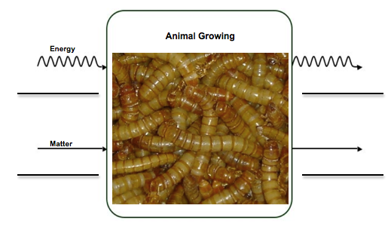
2. Using what you learned in your investigation, show what happens to matter and energy in our own bodies when we grow.
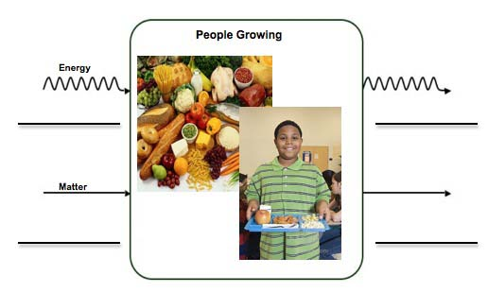

Activity 4: Food Helps Animals Move

General Overview
Review mealworm experiment ~ 5 minutes
Exercise demo with process tool ~ 30 minutes
Air is Important for Movement ~ 15 minutes

Total Estimated Time: 50 minutes

Purpose
The purpose of this activity is for students to begin learning about how cells use food to move. In the mealworm investigations students learned that some of the food animals eat becomes part of their bodies, but not all and food/matter does not simply disappear. Today they will learn that only some of food helps us grow, but much of this food is used to help animals move and function. Students engage in basic exercise activities in which they record the different things happening in their bodies (e.g., breathing harder, getting hot, being able to move body parts etc). Students begin to use the process tool to describe what happens when they move. They identify food and air/oxygen as being the materials they take in (that is why they breathe, especially breathing hard when they exercise). They learn that they breathe out gases when they exercise and test this air for carbon dioxide using a simple demo with BTB. Then students discuss the types of energy input (chemical energy in food) and what types of energy forms they show as they exercise (motion, getting warm; heat).

Then they read about why we breathe harder when we exercise. This involves tracing air through the human body to cells. Students learn about oxygen that enters the lungs and is transported by blood vessels to the cells. They learn that cells need oxygen in order to get the energy they need from foods.

Materials
Data from mealworm investigation for review
BTB solution
Clear paper cups
Straws
Process tool for movement/running
Copies of Food Helps Animals Move
Copies of Air is Important For Movement
Powerpoint: Trace Air to Cells

Advance Preparation
Prepare BTB solution
Assembling 1 cup and 1 straw per student
Make copies of student handouts if not provided by MSU
Make overheads if not provided by MSU
Have process tool ready for use.

Procedures

Review Mealworm data ~5 minutes
Review the mealworm data with the class. Reminds students that they learned that part of the food mealworms eat becomes part of their body during growth. Consider going back to the process tool to show growth (that liquid and solid food becomes solid materials in body and that chemical energy in food becomes stored chemical energy in the body). Then remind students that overall the mass of the food and mealworms decreased, so although the mealworms were growing, something else what happening that made the mass decrease. Tell them that today they will learn about other ways that animals use and change food in their bodies.

Exercise Activities/Movement Process Tool ~35 minutes

This activity relies a great deal on macroscopic observations to help build and initial understanding of the process occurring during exercise. This uses the process tool and several key questions and demos to point out different energy and matter inputs and outputs.

Tell students that today they will talk about how the body uses food in order to move. Place the Movement/running process on the process tool. Place “food” as solid and liquid material inputs. Ask students about why they think we need food to move.

Then tell students they are going to do several exercises and that it is important to make observations about what is happening with their bodies as they exercise. Have students do jumping jacks or possible run around the school. Make sure that students do enough exercises to identify the following 3 things: 1) they breathe harder, 2) they get warm or hot, and 3) they are moving a lot. Whatever activity seems appropriate or works for you as long as it gets kids a chance to identify and think about these everyday observations.

Ask students what other materials go into their body when they exercise (Air). Try to get students to identify oxygen as the gas that goes into their body. Ask students what materials come out of their bodies (they breathe so air is coming out; they may sweat so water is coming out).

Tell students that they are going to test the air they breathe out when they exercise. If you are concerned about students conducting this investigation individually consider having 1 student do it as a demo for the class. Have the student come to the front of the room. Make sure they are fairly relaxed at this point. Tell students that the BTB solution will tell how much carbon dioxide the student breathes out. Have the student blow through the straw; the color of the BTB should change to yellow to indicate CO₂. Then have the student exercise, maybe run outside, do push-ups or jumping jacks and re-do the BTB demo. Help students see that carbon dioxide is one of the gas products of movement. Place this on the process tool. Also, tell students that sweat is a liquid product of movement, but that we also breathe out gas water vapor when we breathe.

Now have students complete the process tool for energy. Ask students to think about their 5 forms of energy- light, chemical, motion, electrical, and eat. Ask them which of these are the energy input- remind students that food has chemical energy but oxygen does not.

Then ask students if they observe anything during exercise that shows how the chemical energy in food changes (it changes to motion, and to heat).

Pass out Food Helps Animals Move. Using this student worksheet and the process tool, review the entire process tool for movement. Point out that most of the materials that leave our bodies when we move are in the form of gases.

Ask students if this helps them explain what may have happened in the mealworm experiment. What could have happened to the food that did NOT contribute to growth?

Air reading and powerpoint 25 minutes
If time, consider using the Air is Important for Movement reading. Pass out copies to students. The reading prompts students to think about why we breathe, and what happens to air. In order to make sense of how cells use food to move, students will need to understand that this requires oxygen. Let students share their ideas to the questions at the end of the reading.

Other questions and key ideas to keep in mind include:

- Eating and breathing are related because they provide materials the cells need to work- the materials can be in the form of solid, liquid or gas
- Food goes beyond the stomach and intestines- it goes to the cells
- Air goes beyond the lungs- it goes to cells.
- Air is a form of matter

Also consider using the powerpoint to help trace air/oxygen from the lungs to the cells.

In the next activity students will zoom into the atomic-molecular scale and use the models to show what is really happening when they exercise.
Name: ____________________________________ Date: ____________

Food Helps Animals Move

- Think about how food and air help you move and exercise. How does matter and energy change in your body when you move and exercise?
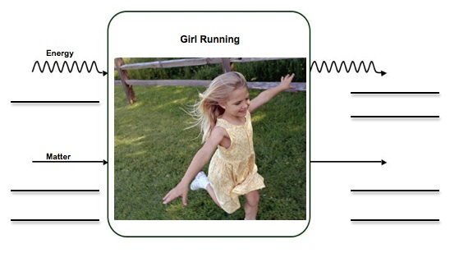

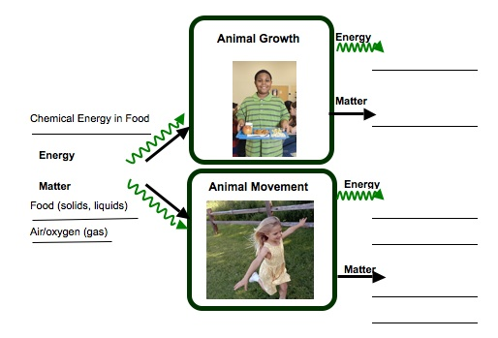
- Some food and air helps animals grow and some helps animals move. Trace the two different paths that matter and energy take in the body.
Air is Important For Movement

Many people think that we breathe because we need oxygen to live. That is only partly right. They have left out an important part of the explanation of why we breathe. They have not explained WHY we need oxygen or HOW the body uses that oxygen. A good explanation that explains why we need oxygen or how the body uses oxygen might be that we breathe so our cells get oxygen to combine with food. That is how our cells get the energy that is stored in food. You have learned how food reaches your cells, but what about oxygen? How does oxygen reach your cells?

Let’s answer that question by following one breath of air that you breathe.

How does oxygen get to all of your cells?
Air contains oxygen, which your cells need, as well as many other things that your cells do not need. Some of those other things are gases such as nitrogen, carbon dioxide, and water vapor. Air also has bits of dust and smoke and pollen in it. But air is mostly made up of gas. These gases are taken inside the body.

Your lungs
With every breath, your lungs fill up with air. Most of that air, including all of the materials your body doesn’t need, you breath right back out again. But you don’t breathe out all of the oxygen that you breathe in. Some oxygen stays in your body and goes to all your cells. That means that some of the gases you take into your body stay in your body and travel all the way to your cells.

Do you have an idea how oxygen gas gets to your cells? Talk with your classmates about how you think this happens.

To your blood
Your blood carries both food and oxygen to your cells. The inside of your lungs is sort of like a sponge. Lungs have lots of tiny spaces for the air to go into, and each one of these spaces is surrounded by tiny blood vessels. Some of the oxygen gas from the air goes into the blood.

To your cells
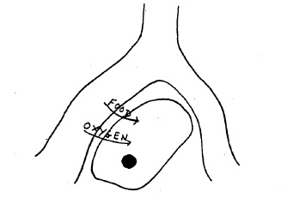
From your lungs, the blood takes oxygen to the cells in all parts of your body. Your cells get the energy they need by taking both food and oxygen out of your blood. Remember, we breathe so our cells get oxygen to combine with food. That is how our cells get the energy that is stored in food.

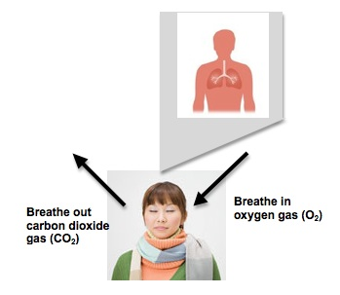
Think about what you have learned about oxygen and talk about the following question with your classmates:

Have you ever heard that people breathe in oxygen and breathe out carbon dioxide? You know what happens to the oxygen that we breathe in, but why do we breathe out carbon dioxide? If we breathe out carbon dioxide, where does it come from?

Use powerpoint to help students trace air from lungs to cell.
Activity 5: Cell Respiration

General Overview
Review exercise activity and process tool from Activity 4 ~ 5 minutes
Read about Cell respiration ~15 minutes
Modeling Cell Respiration ~ 30 minutes

Total Estimated Time: 50 minutes

Purpose
In this lesson students zoom in on what happens when they exercise or “use” food to get usable energy for the cells. They look learn about cell respiration at the atomic-molecular scale and observe it as a process of rearranging atoms. Up until this point, most of the activities have been at the macroscopic to microscopic level (body, organs, cells) with only a few connections to atomic-molecular. Students first read about cell respiration and then they are given molecular model kits and build the matter inputs for cell respiration and identify which of these materials has chemical energy. They then rearrange these into the matter products and learn that these products do not have chemical energy. The summary questions engage them in making sense of how matter and energy changed on an atomic-molecular level. Importantly this lesson engages students in the principle: conservation of atoms.

Materials
Student copies of What Is Respiration reading
Student copies of Modeling Respiration
Molecular model kits

Advance Preparation
Gather student worksheets
Prepare molecular model kits for use

Procedures

Review and Preview ~5 minutes
Review what students learned during activity 4 when they constructed the process tool for exercising and identified important matter and energy changes that happen during movement. Tell students that today they are going to learn about how students use food to get usable energy. Also, remind students that they learned in the mealworm investigation that the overall mass decreased, so today’s activity will help explain where the mass went.

Read about Cell Respiration ~15 minutes
Ask students what they think of when they hear the word “respiration”. Most students will mention something about breathing. Ask students if they have ever heard of cell respiration. Have them share what they know, or what they think cell respiration is. Then pass out the reading What is Respiration. As a class, read through the brief description. Consider using the process tool as you read, tracking the matter inputs and outputs that are described.

After the reading in finished, tell students that today they are going to think about what is happening to molecules inside each cell as they respire. How does a food molecule/glucose ultimately become carbon dioxide?

Modeling Cell Respiration ~30 minutes
In groups students will build models of glucose and oxygen and model the process of cell respiration, accounting for all the atoms, and paying attention to the types of bonds in the substances. Consider walking through their handouts as a whole group as opposed to letting them do the activity on their own. That way focused discussions could occur through the modeling activity.

Again keep in mind the following key ideas:

- Scale- do the students understand that food and air can be traced beyond the lungs and stomach to cells? Can they explain how eating and breathing are important at atomic-molecular scale in terms of rearranging atoms?

- Matter- do the students understand that food and air are materials that the cells need to work. Do they realize that food can be both solid and liquid and that all three forms of matter are taken in by the body and transported to cells? Can they trace gas exchange beyond the lungs? Can they trace food beyond the stomach? Can they describe cell respiration as the means for changing these materials? Can they account for atoms?

- Energy- can they recognize that food has chemical energy because of the type of atoms and bonds it has? Water, air, vitamins do not have chemical energy, although our bodies still need them to function. Do they recognize that chemical energy from glucose is changed to other motion energy and heat in the cells? Do they recognize that food cannot become energy?
What Is Cell Respiration
Animals need food and air to help them grow, move, and keep all their body parts functioning. You learned that animals can grow and move when food and air gets to their cells. But what happens to those materials when they reach the cells.

Let’s think about a single cell, one of your brain cells, for instance. Your brain cell needs energy to think about reading this page. How will it get that energy?
At first the energy that the cell needs is stored in food as chemical energy. The food is carried by the blood to the cells. The blood also has something else that the cell needs to get energy from food, oxygen. The cell gets food and oxygen from the blood.

Now that the cell has food and oxygen, it can get the energy it needs. It changes the chemical energy found in food into other usable energy, such as motion energy, heat, and other forms of chemical energy. When it changes food, the cell makes waste products that it doesn’t need: carbon dioxide and water. How can it get rid of those waste products? Give them back to the blood, of course!
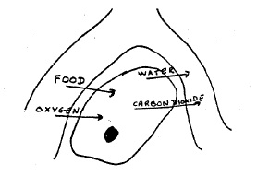
As cells work, they give off carbon dioxide and water that they do not need. These materials leave the cells and go back into the blood vessels. Eventually the water and carbon dioxide leave our bodies. Carbon dioxide leaves when we breathe out. Water leaves when we breathe, sweat, or even as urine.
Cells get chemical energy from food through cellular respiration. Cellular respiration is the process by which cells change chemical energy into usable energy by combining food and oxygen. Scientists call this cellular respiration because it happens in every single cell, not just in the lungs or in the stomach. Right this very second, every one of your trillions of living cells is getting its energy from combining food and oxygen you get from eating and breathing!

You eat many different kinds of food, but your body changes all of them to glucose. Glucose is the energy-containing food that cells use for respiration. When cells combine glucose with oxygen, the cells change the chemical energy stored in the glucose. The energy changes into new forms: motion energy and heat. Think about the type of energy form you observe when you walk or run, or how your body temperature stays around 98.6°F. There are also two matter products that the cells don’t use. These matter products are carbon dioxide and water.

The equation below shows how matter and energy change in cells:

MATTER Glucose + Oxygen → Carbon dioxide + Water
ENERGY Chemical Energy → Motion Energy + Heat

This means that glucose (food) and oxygen react and eventually the atoms that make up these materials are rearranged into carbon dioxide and water. The chemical energy that was in the glucose changes forms. It changes into motion energy and heat.
Name: ___________________________________ Date: ______________

Modeling Cell Respiration

In your groups, you will use molecular model kits to model the process of cellular respiration. You will build the substances that go into cells, and then use the models to show how those substances change inside cells. Follow the directions below to build your models:

Look at the equation for cell respiration:

MATTER Glucose + Oxygen → Carbon dioxide + Water
ENERGY Chemical Energy → Motion Energy + Heat

Glucose is a sugar that comes from food, and oxygen comes from the air that you breathe. In order to model cell respiration, you will first need to build your glucose molecule and your oxygen molecules.
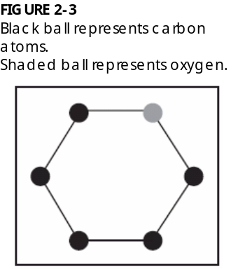

Build Glucose Molecule

Step 1: Build the Glucose Ring. Look at the diagram to the right. This shows the first part of the glucose molecule. It shows 5 carbon atoms (black) and 1 oxygen atom (grey). This ring will start your glucose molecule.

Step 2: Look at the diagram and circle on the right. You will work first with the carbon that is to the left of the oxygen in your ring. On this carbon, first connect a second carbon. On this second carbon, attach 2 hydrogen atoms and 1 oxygen. Attach another hydrogen to the oxygen. Then attach 1 hydrogen to the carbon that is on the ring. There should be no empty holes.
Step 3: Move to the next two carbons on the ring. Attach 1 oxygen and 1 hydrogen to these carbons. Then attach another hydrogen to each oxygen. Make sure it looks similar to the diagram to the right. There should be no empty holes on these atoms.

Step 4: Move to the last two carbons on the ring. Attach 1 oxygen and 1 hydrogen to these carbons. Then attach another hydrogen to each oxygen. Make sure it looks similar to the diagram to the right. There should be no empty holes on these atoms.

Check that there are no empty holes on your glucose molecules and that it looks like the diagram. Now you’re ready to build your oxygen molecules!

Build Oxygen Molecules.

Step 5: You will need 12 oxygen atoms to build 6 oxygen molecules. Each molecule contains 2 oxygen atoms. These are bonded together twice (a double-bond). Build 6 oxygen molecules that look like the molecule on the right,
Look at your glucose and oxygen molecules. Glucose is a sugar that our bodies get directly from food or from breaking down more complex substances. Oxygen comes from the air that we breathe. Count the number of atoms that you have total.

How many carbon atoms are in your molecules? ____________
How many oxygen atoms are in your molecules? ____________
How many hydrogen atoms are in your molecules? ____________

Look at the glucose molecule. Does glucose have chemical energy? Why or why not? _____________________________________________________________________
_____________________________________________________________________

Look at the oxygen molecules. Does oxygen have chemical energy? Why or why not? _____________________________________________________________________
_____________________________________________________________________

Record this information in the table below:
 | Matter |  |  | Energy
 | Carbon atoms | Oxygen atoms | Hydrogen atoms | Chemical Energy  Yes or No?
Glucose
Oxygen
Total Atoms |  |  |  | LEAVE BLANK

Think about this question: Using the information above, do you think oxygen supplies chemical energy for the cell to work?
The glucose and oxygen make in to a cell in your brain. In order for that cell to have usable energy, it must break down the glucose molecule. Use what you know about cell respiration to break down the glucose and oxygen molecules to make the waste products of cell respiration: carbon dioxide and water.

Glucose + oxygen carbon dioxide + water

Below are diagrams of carbon dioxide and water to help you reassemble your molecules. Make as many carbon dioxide and water molecules as you can with the atoms that were originally in the glucose and oxygen.

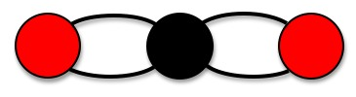
WATER MOLECULE
CARBON DIOXIDE MOLECULE

Once you have made your carbon dioxide and water molecules, count the number of atoms in these molecules.

How many carbon atoms are in your molecules? ____________
How many oxygen atoms are in your molecules? ____________
How many hydrogen atoms are in your molecules? ____________

Check to see that you have the same number of atoms that you started with. There should be no extra atoms either. All of the atoms you began with should be part of either a carbon dioxide or water molecule. Remember atoms cannot be created or destroyed!

Look at the bonds in the carbon dioxide and water molecule. What type of bonds are they? Do you think these molecules have chemical energy? Complete the table below.
 | Matter |  |  | Energy
 | Carbon atoms | Oxygen atoms | Hydrogen atoms | Chemical Energy  Yes or No?
Began with…
Glucose

Oxygen

End with…
Carbon Dioxide
Water

Answer the following questions:

1. The carbon dioxide we breathe out contains carbon. Using what you learned about cell respiration, where was this carbon atom before it was in carbon dioxide? ________
__________________________________________________________________________________________________________________________________________________________________________________________________________________

2. You modeled that cell respiration is a process where cells take food with lots of chemical energy and rearrange the atoms into things that do not have chemical energy. What happens to the energy during this process? ______________________________
__________________________________________________________________________________________________________________________________________________________________________________________________________________
Activity 6: What Happens When Animals Lose Weight

General Overview
Setting Up Crickets- Predictions ~ 15 minutes
Results and Process Tool Discussion ~ 35 minutes

Total Estimated Time: 50 minutes

Purpose
The purpose of this activity is for students to think about what happens when animals/people lose weight. By measuring the mass of cricket, students learn that crickets lose weight over time, sparking discussion of where the mass goes. They use the process tool to track changes in solid body part material into gases, relating these gases back to their exercise activities. Students have learned about cell respiration, and thus recognize that gases (and some water) are the end matter products of this process. This gives kids an opportunity to observe what would happen over time if an animal’s body started using stored chemical energy sources for cell respiration (note that the starting matter input can be different for weight loss compared to movement- the matter input is body structure/fat/stored materials).

Materials
Crickets
Cups or other container with air ventilation holes
Digital Balance
Copies of Cricket Observations, which includes What Happens When Animals Lose Weight
Process tool for weight loss

Advance Preparation
Prepare crickets for investigation.
Make copies of student handouts if not provided by MSU
Have process tool ready for use.

Procedures

Setting Up and Predictions ~15 minutes
This investigation has students observe house or field crickets over a couple of school days.
The crickets can be purchased from a local pet or bait shop. Show students the crickets. Place a container on the digital balance and zero the scale. Then add 15 or more crickets to the container and find the start mass for the crickets. Have students record start mass on their handouts. Then ask students to predict whether the mass will go up, down or stay the same over time. Have them write their predictions and then allow students to share these.

Monitor crickets
We are not sure how long it will take for the .1g balance to detect a change in mass, so monitor the cricket a couple times a day until you observe a detectable difference. What’s the decrease in mass is observed, set aside at least 30-45 to discuss what happened using the process tool and procedures below.

Weight Loss and Process Tool ~35-45 minutes
The mass of the crickets will decrease because crickets are giving off more materials than they are take in—thus, they lose weight. Have students record the End mass of the crickets and respond to questions on their Cricket observation handout.

Then, using the process tool, help students trace matter and energy during this activity. The starting matter is “cricket body parts”- that is what gave the crickets their mass, so if the mass went down, where did it go? Point out that there mass seems to have disappeared, so the matter transformation must include a gas. Help students make a connection back to the exercise activity they did. Energy starts as chemical energy stored in the cricket bodies and changes to motion energy (to help organs function) and heat.

After the investigation, the crickets can be released outside.

Optional: Consider using the additional reading material to help students complete their process tools. They may struggle with identifying materials products and reactants on the process tool, so they could read about what is happening at the cell to change matter and energy.

Example Cricket Data:
Cup: 13.6g (including mass of perforated lid)
Crickets: 3.0g (roughly 15 house crickets)
Total Start Mass: 17.6g

Time | Mass
0hr | 17.6g
3hr | 17.5g
6hr | 17.4g
8hr | 17.4g
18hr | 17.3g
Name: _______________________________________ Date: _______________

Cricket Observations

Use this sheet to make observations of your class crickets.

Your Prediction

- What is the starting mass of your crickets? _____________

- Do you think the mass of your crickets will go up (increase), go down (decrease) or stay the same? ________________________

- Explain your prediction. Why do you think that? _____________________________
_________________________________________________________________________________________________________________________________________________________________________________________________________

Results and Conclusions

- What was the end mass for your crickets? _________________

- If there was a change in mass, explain what you think happened. _______________
____________________________________________________________________________________________________________________________________________________________________________________________________________________________________________________________________________

What Happens When Animals Lose Weight

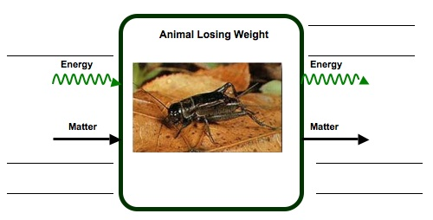
- What do you think happened to the matter and the energy in the crickets?

7. Think about your cricket investigation and what you learned about how animals change matter. When people and other animals lose weight, where does the mass go? What happens to the mass? _______________________________________________
__________________________________________________________________________________________________________________________________________________________________________________________________________________

Activity 7: Assessment or Extension: Black Bear Article

General Overview
Introduce activity ~5 minutes
Black Bear Article ~25 minutes
Whole group Discussion & Process Tool ~20 minutes

Total Estimated Time: 50 minutes

Purpose
At this point students should know that some materials have chemical energy because they contain C-C and C-H bonds and students should be familiar with the processes of cellular respiration. In this activity, students will learn about two materials with chemical energy: sugar and fat and engage in thinking about matter and energy transformation that occur in metabolic processes.

When students finish this activity, they should be able to:
- Explain why sugar and fat are energy sources for organisms growth, function, and movement in terms of chemical energy
- Identify chemical energy sources in the process of cellular respiration
- Explain energy transformation and heat dissipation in the process cellular respiration

Materials
Copies of Black Bear Hibernation handouts for students
Overheads of Process Tool, Sugars and Fats and Cellular Respiration, if needed
Large Process Tool

Advance Preparation
Make copies of student handouts
Make overhead transparencies if needed

Procedures
- Introduce the black bear article. Engage the students by talking about the Problem listed on page 1 of their handouts. Ask students if they have ideas about how to explain what’s happening to the bear during hibernation. Review the procedures on the first page of the handout.

- Have students read the Black bear article independently, but they can complete the Process Tool in partners. Remind students to think about the different types of energy (chemical energy, heat, motion energy, etc) as they complete their charts. You may have to help students make connections between macroscopic, visible things happening to the beat (eating nuts, heart beating, warm body) and the microscopic and atomic-molecular processes that are happening in the bear’s body.

- After students complete the process tool have them talk about and respond to the discussion questions.

- As a class, then complete the process tool. An important goal of this activity is for students to understand that matter/mass is not converted into energy. Matter must be accounted for and energy must be accounted for. Another important goal is for students to connect the visible evidence (heartbeat, body temperature) with atomic-molecular processes and energy transformations. Try to guide students to thinking about these things during the discussion. After completing the process tool, have students talk about their responses to the discussion questions. Keep in mind the two goals above. Use the additional transparencies if needed.

Name:_____________________________________ Date:_______________
Black Bear Hibernation
Investigation problem*

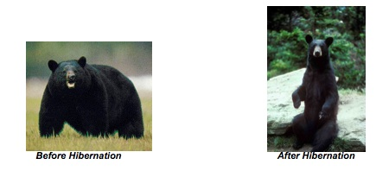

You will explore the following problem:

Why do black bears lose fat during hibernation? Where does the fat go? How can we explain this using the concept of energy?

Procedures:
Read the article - Black Bear Hibernation. As you read think about how the bear gains mass by storing food for hibernation and how the black bear uses its stored fat during hibernation.

After you read the article, complete the energy transformation chart based on what you know about what is happening in the bear. Identify what happens in the cells of the bear and explain how energy and matter change in these cells.

Then in partners or small groups, compare your charts and discuss what you think is happening while the bear hibernate. Discuss the following questions:

What chemical process is happening while the bear hibernates? WHY is this process occurring?
Where does the bear get energy for its body to function while it sleeps? Explains what happens to the energy through this process.
The bear loses mass as it sleeps. Where does this mass go?

After your group discusses the energy charts and the three questions above, then complete the summary questions at the end of the activity. You may be asked to share your ideas or ideas from your group with the rest of the class, so make sure to explain as much as you know about what is happening as the bear sleeps.

BLACK BEAR HIBERNATION

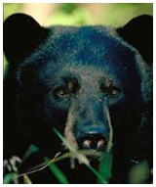

Black bears are classified as members of the order Carnivore, and their teeth, claws, strength, and size make them look like predators. The bears’ body is designed for storing fat and conserving heat in the winter, so they lack the agility required to catch healthy, adult prey. The few prey they catch are mainly nesting birds, newborn mammals, penned livestock, or spawning fish. Their long canine teeth are used mostly for biting into insect-ridden logs or for tearing apart carrion. Their claws are tightly curved for tree climbing, unlike grizzly claws, so black bears have an advantage over grizzly bears, deer, and wild hogs when competing for acorns, nuts, and fruits.

A problem for bears living in northern evergreen forests is that fruits and nuts are very scarce after August. Acorns, beechnuts, and hickory nuts, which are fall foods, are scarce or absent in many of those forests, leaving the bears little food in fall. As a result, the hibernation of black bears is more an adaptation for escaping winter food scarcity than an adaptation for escaping winter cold. In the months before hibernation black bears can gain up to forty pounds of fat per week. Hibernation lasts up to 7 months in the northern regions. Bears that find food year-round in the South may not hibernate at all, but black bears in the North hibernate so deeply that they may be jostled and prodded for several minutes in mid-winter before they awaken. To survive long winters without eating, drinking, exercising, or passing wastes, hibernating bears cut their metabolic rates in half. Sleeping heart rate drops from a summer rate of between 60 and 90 beats per minute to a hibernating rate between 8 and 40 beats per minute. Body temperature drops only slightly, though, from 99-102 °F in the summer to 88-98 °F during hibernation. The body temperature of hibernating bears is appreciably higher than that of other hibernating animals. During the period of hibernation, the black bear usually lose 15 – 25% of its body weight, most of which is fat.

After reading this article, think about information that was given that can help you explain the process happening in the bear and how energy can help explain the loss of fat after hibernation.

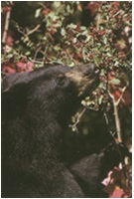
For example, before hibernation bears eat a lot. They eat fruit, nuts, acorns, insects, and certain leaves and plants. They catch occasional small animals, but lack agility to catch most adult prey. In the months before hibernation black bears can gain up to forty pounds of fat per week. Think about the types of molecules that are being made and stored in the bears’ body during the summer and fall months. What do you know about the energy stored in these types of molecules? What does this information tell you about how the bears get and store energy for hibernation?

Think about these questions and complete the first part of the Energy Chart.

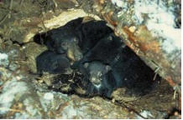
Now think about what happens during hibernation. The sleeping heart rate drops from a summer rate between 60 and 90 beats per minute to a hibernating rate between 8 and 40 beats per minute. The bears’ body temperature drops from regular 99-102°F to 88-98°F during hibernation. But the bear is still alive and all of its body functions are still happening. Where does the bears’ body (and organs) get energy to keep functioning? What metabolic process helps you explain what is happening? What energy transformations are happening during hibernation?

Think about these questions and complete the second part of the Energy Chart.
Summary Questions

First complete the process tool. Then answer the questions below.
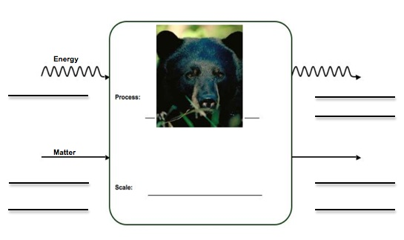

1. Where do you think the mass of the bear’s fat goes during hibernation?

2. Where does the bear get energy for its body to function during hibernation? What form of energy is it?

3. Energy is required to keep the bear’s heart beating during hibernation. Where does the energy come from and how does it change form for the heart to beat?

4. Energy is required to keep the bear’s body temperature warm. Where does the energy come from and how does it change form to keep the bear’s body warm?

Sugars and Fats: Which has more energy?

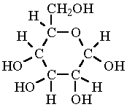
Glucose molecule

Fat molecule

WHICH MOLECULE IS MORE ENERGY-RICH?

After black bear eats fruits, the glucose molecules in the carbohydrates of fruits is digested and reconstructed into fat molecules. Fat molecules contain more C-C and C-H bonds than glucose. Think about the types of bonds in each molecule and explain why fat might be more energy-rich and an efficient source of energy for the bear.
What’s Happening During Respiration?

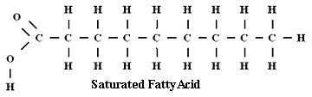

+ O=O O=C=O + H-O-H

FAT OXYGEN CARBON DIOXIDE WATER

What type of bonds are in the fat molecule? Are these high energy or low energy bonds?

What type of bonds are in the CO₂ and H₂O molecules? Are these high energy or low energy bonds?

Using this information, explain what is happening to energy during this process

* This activity was originally developed by Hui Jin.
This article was developed from two sources: Rogers, L. (1992). Watchable wildlife: the black bear. USDA Forest Service, North Central Forest Experiment Station, St. Paul Minnesota. Lundberg, D. A., Nelson R. A., Wahner, H. W., Jone, J. D. (1976), Protein metabolism in the Black bear before and during hibernation. Mayo Clinic Proceedings. 51(11): 716-22.

